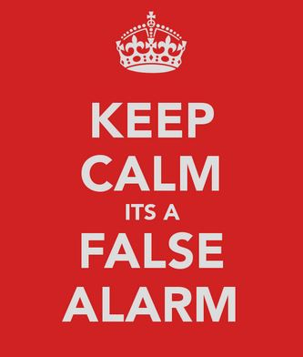
Why should I be concerned about false alarms?
False alarms not only put unnecessary pressure on emergency response services and the authorities who manage first responder dispatches, but can also result in false alarm fines for homeowners. Frequent false alarms may also impact false alarm by-laws in your region. Playing an active role in reducing false alarms can help ensure that emergency response teams will be available to respond to true emergencies when you and your community members need them most.

What are false alarms vs. false dispatches?
A false alarm is an alarm that is accidentally
activated and there is no true emergency
situation. False alarms can cause false dispatches. A false dispatch occurs when emergency response teams are unnecessarily dispatched to address the
false alarm.

Playing an active role in reducing
False Alarms can help ensure that emergency response teams will be available to respond to true emergencies when you and your community members need them.
most.

Helpful Hints to Prevent False Alarms:

- Learn to disarm your system quickly.
Train each person who will be using the alarm system. Anyone with a key to your door must be trained - and that includes family members, Staff members, neighbours, cleaners, tradesmen and any others who will need to use the system. Occasionally have each person actually turn the system on and off to keep it fresh in their mind.
-Don't just explain it to them verbally, make them try. If you change the code, be sure everyone with a door key is notified.

- Know how to cancel a false alarm.
Remain calm and enter your code to disarm the system. Then wait for the Monitoring station to call you. Or you can call them. Have the monitoring station number handy, (you should have received one by your keypad) Know your code number or "All OK" Password needed to cancel a false alarm. Let the station know that it is a "False Alarm" and everyone is OK. That way the police will not be called.

- Check all doors and windows before turning on the alarm.
Make sure all doors and windows are closed and locked properly, even if they aren't attached to the alarm. Some alarm sensors can be affected by flowing curtains, wind gusts, noise, birds and animals which can enter through unprotected openings and cause false alarms.

- Keep the buttons out of Children's Reach.
Panic buttons and emergency activated features can be appealing to children. Teach them that playing with the buttons is not OK. It is for emergencies only and can cost families a hefty bill if toyed with.

- Maintain and clean your sensors
Wipe sensors, smoke detectors and contacts down with a lint free cloth or dry paint brush. If you want, use bug spray with-in the area. Remove plants, shrubs or branches that can grow over or obstruct the sensors path way. No need to get an alert because a bug crossed the sensor...It happens! Also, decorations, balloons and streamers can cause false alarms, so be sure to remember that when decorating. Call us for annual maintenance or when needed. There is also a maintenance package we can offer if you wish.

- Test your system monthly
Manually trip your alarm from a few different access points. You'll have about 15-30 seconds to disarm your system each time before the monitoring station calls you. If the alarm doesn't go off, it might be time to change the batteries. Start there, and then try again. If you need help, try reviewing your manual for instructions, if you still need help, please call us for assistance. Keep in mind that most insurance companies require you to do frequent tests on your system.
Thank you
for your help!

250-485-4366
5998 Sawmill Road, Oliver

Authorized Dealer

Cellular Security Cameras

Please Read the following information!

www.StrikeAlarms.ca
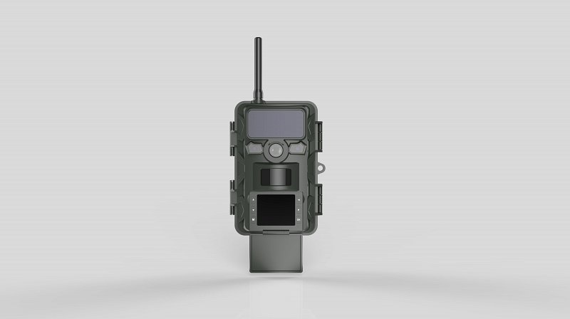
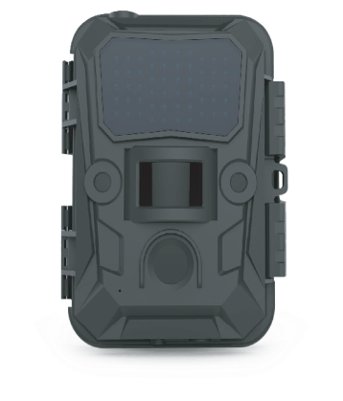
When You're Under Attack
...We Strike Back!

Oliver
250-485-4366

Osoyoos
250-495-5959

Helpful Hints
when using your alarm system and preventing ...

False Alarms

We STRIKE Back

